Elliptical Cross Sections

Definition
# Source: AI Source: Provided by: [Data Path: Persons Table -> ID Column: 1, Name_En Column: Motasem Essam] -> From: [ChatGPT] on [7/25/2026]
An Elliptical Cross Section is a two-dimensional region formed when a plane intersects a three-dimensional solid and the resulting boundary is an ellipse.
An ellipse is a closed curve in which the sum of the distances from every point on the curve to two fixed points, called the foci, is constant.
An elliptical cross section has two principal dimensions:
- Major Axis: The longest diameter of the ellipse.
- Minor Axis: The shortest diameter of the ellipse.
Its shape depends on the geometry of the solid and the position and orientation of the cutting plane.

Geometric Representation
# Source: AI Source: Provided by: [Data Path: Persons Table -> ID Column: 1, Name_En Column: Motasem Essam] -> From: [ChatGPT] on [7/25/2026]
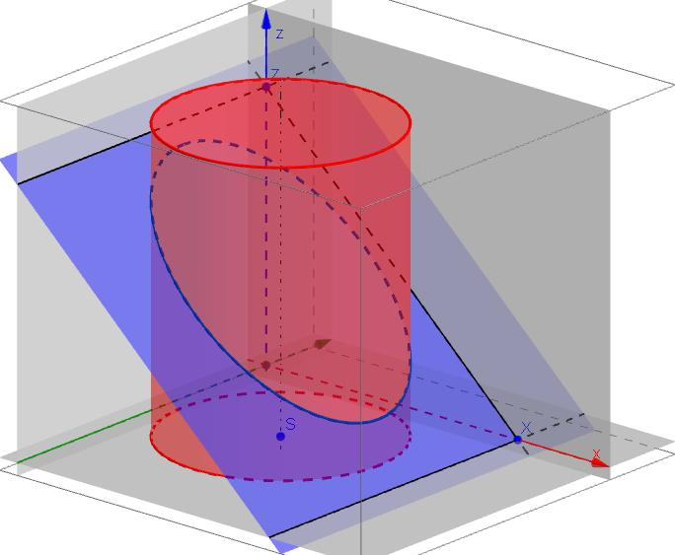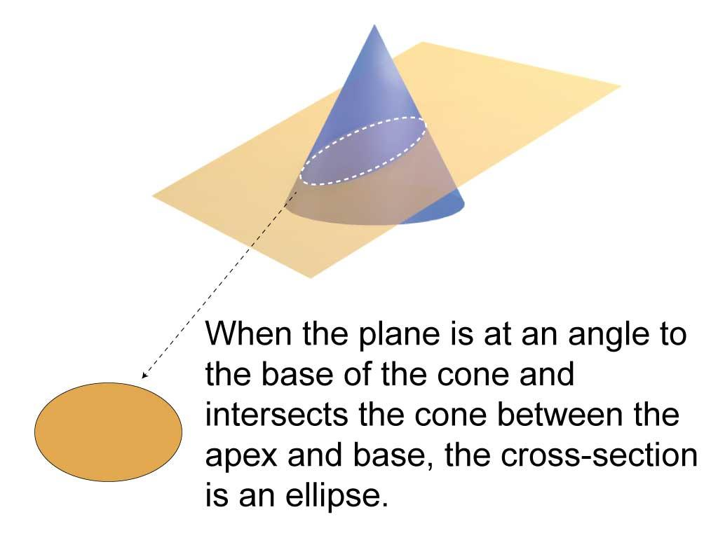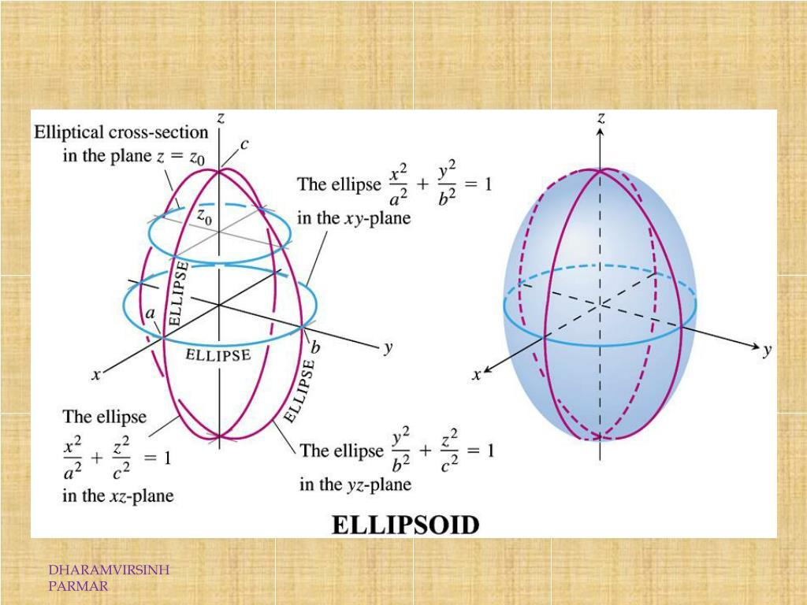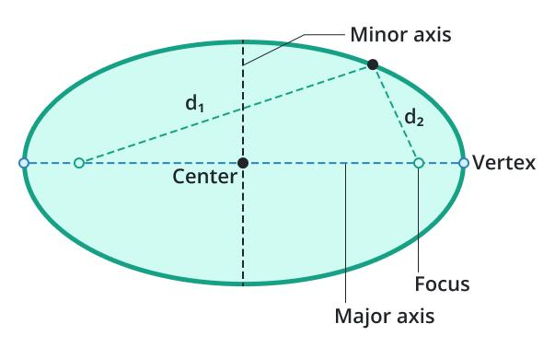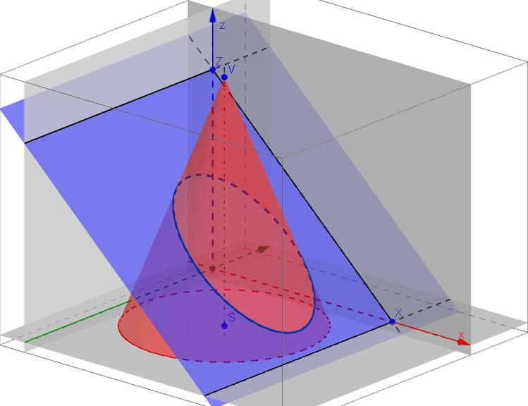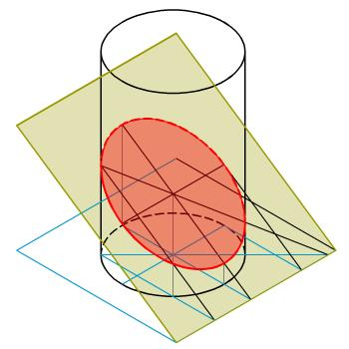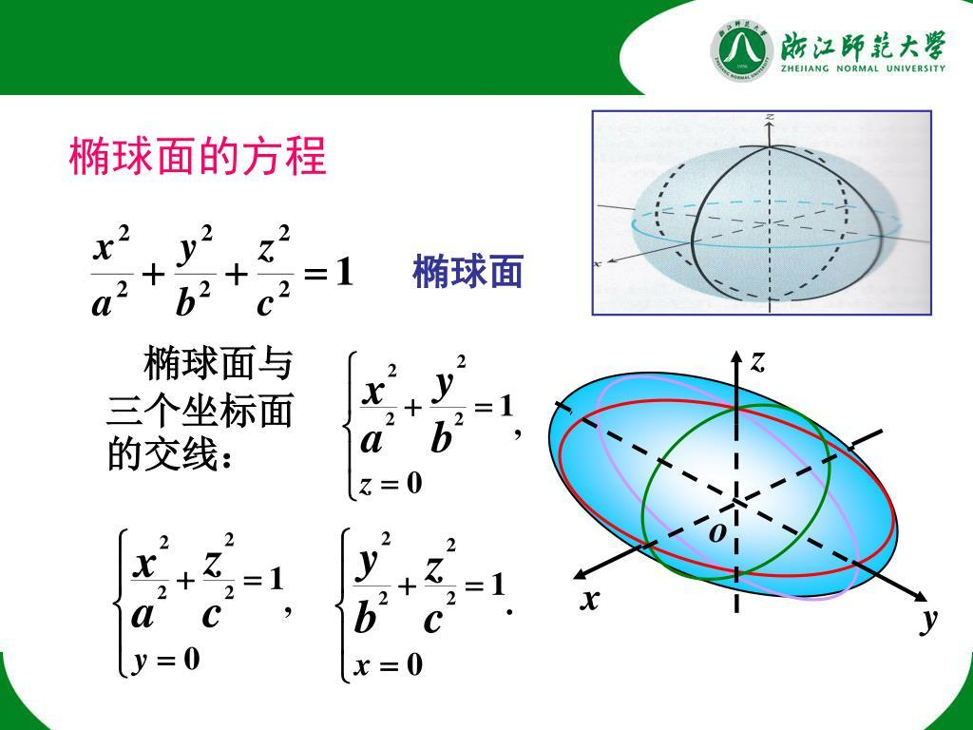

Geometric Structure
# Source: AI Source: Provided by: [Data Path: Persons Table -> ID Column: 1, Name_En Column: Motasem Essam] -> From: [ChatGPT] on [7/25/2026]
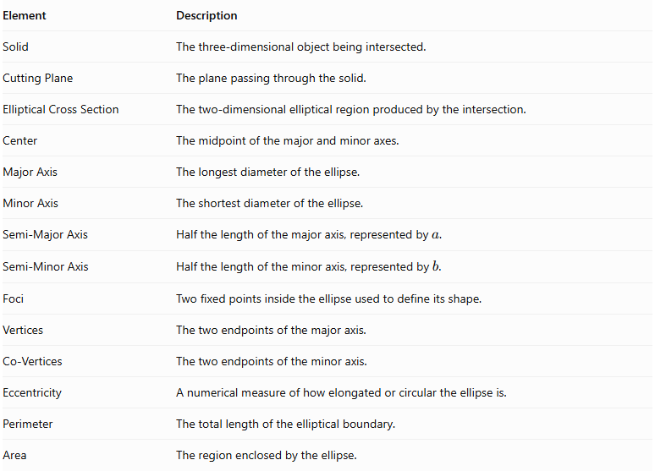
Element | Description
Solid | The three-dimensional object being intersected.
Cutting Plane | The plane passing through the solid.
Elliptical Cross Section | The two-dimensional elliptical region produced by the intersection.
Center | The midpoint of the major and minor axes.
Major Axis | The longest diameter of the ellipse.
Minor Axis | The shortest diameter of the ellipse.
Semi-Major Axis | Half the length of the major axis, represented by $a$.
Semi-Minor Axis | Half the length of the minor axis, represented by $b$.
Foci | Two fixed points inside the ellipse used to define its shape.
Vertices | The two endpoints of the major axis.
Co-Vertices | The two endpoints of the minor axis.
Eccentricity | A numerical measure of how elongated or circular the ellipse is.
Perimeter | The total length of the elliptical boundary.
Area | The region enclosed by the ellipse.

Main Characteristics
# Source: AI Source: Provided by: [Data Path: Persons Table -> ID Column: 1, Name_En Column: Motasem Essam] -> From: [ChatGPT] on [7/25/2026]
- The cross section is bounded by a closed elliptical curve.
- It has a major axis and a minor axis.
- The major axis is always at least as long as the minor axis.
- The ellipse has two foci, which determine its geometric shape.
- Its eccentricity satisfies $0≤e<1$.
- Its shape depends on the solid and the cutting plane.
- A circle is a special case of an ellipse in which the two semi-axes are equal.
- An elliptical cross section can be produced by oblique cuts through suitable cylinders, cones, and ellipsoids.

Types of Elliptical Cross Sections

According to Eccentricity

A. Circular Elliptical Cross Section
# Source: AI Source: Provided by: [Data Path: Persons Table -> ID Column: 1, Name_En Column: Motasem Essam] -> From: [ChatGPT] on [7/25/2026]
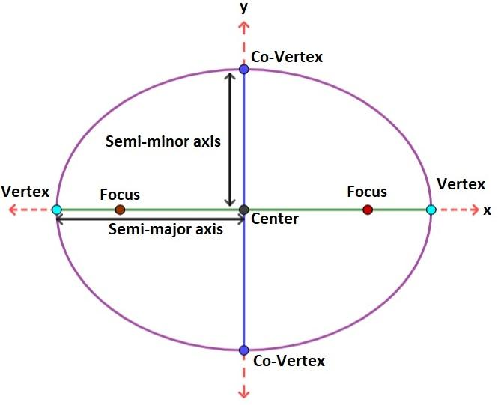
A circular elliptical cross section occurs when the major and minor semi-axes are equal.
$$a=b$$
Characteristics:
- Both axes have equal lengths.
- The two foci coincide at the center.
- The eccentricity is zero.
- The resulting shape is a circle.

B. Non-Circular Elliptical Cross Section
# Source: AI Source: Provided by: [Data Path: Persons Table -> ID Column: 1, Name_En Column: Motasem Essam] -> From: [ChatGPT] on [7/25/2026]
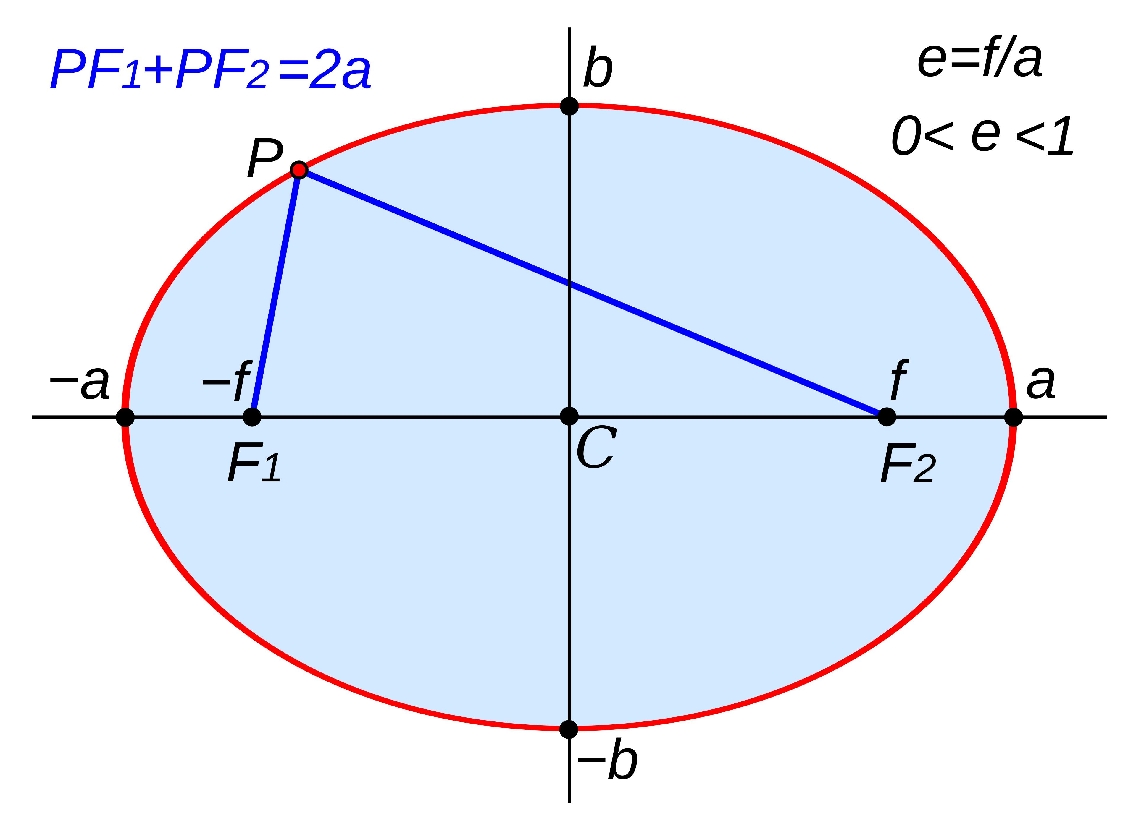
A non-circular elliptical cross section occurs when the major and minor semi-axes have different lengths.
$$a>b$$
Characteristics:
- The major axis is longer than the minor axis.
- The two foci are distinct.
- The eccentricity is greater than zero and less than one.
- The shape is elongated compared with a circle.

According to the Orientation of the Major Axis

A. Horizontally Oriented Elliptical Cross Section
# Source: AI Source: Provided by: [Data Path: Persons Table -> ID Column: 1, Name_En Column: Motasem Essam] -> From: [ChatGPT] on [7/25/2026]
The major axis is parallel to the horizontal reference direction.

B. Vertically Oriented Elliptical Cross Section
# Source: AI Source: Provided by: [Data Path: Persons Table -> ID Column: 1, Name_En Column: Motasem Essam] -> From: [ChatGPT] on [7/25/2026]
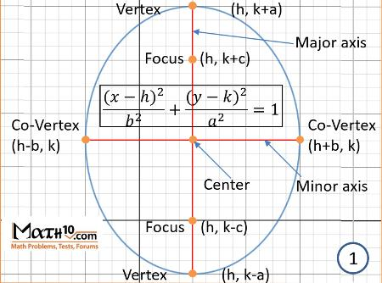
The major axis is parallel to the vertical reference direction.

C. Inclined Elliptical Cross Section
# Source: AI Source: Provided by: [Data Path: Persons Table -> ID Column: 1, Name_En Column: Motasem Essam] -> From: [ChatGPT] on [7/25/2026]
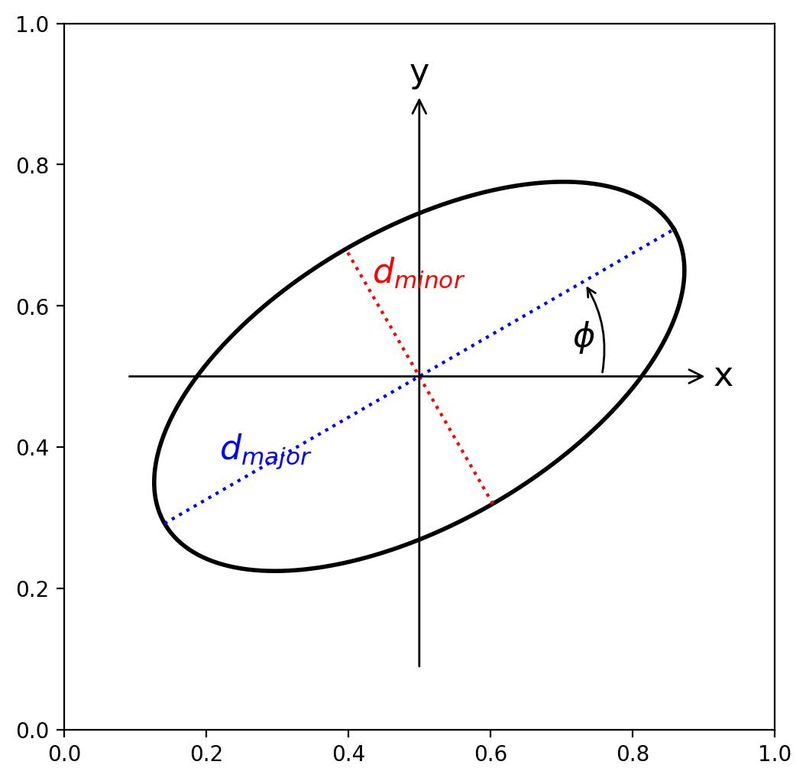
The major axis is inclined relative to the selected horizontal and vertical reference directions.
Note: These are orientations of the resulting ellipse, not separate geometric species of ellipse.

Examples According to Solid Type

Right Circular Cylinder
# Source: AI Source: Provided by: [Data Path: Persons Table -> ID Column: 1, Name_En Column: Motasem Essam] -> From: [ChatGPT] on [7/25/2026]
An oblique plane intersecting a right circular cylinder can produce an elliptical cross section.
- The plane is inclined relative to the circular bases.
- The resulting section is elliptical when the plane is neither parallel nor perpendicular to the cylinder's axis.
- The ellipse's dimensions depend on the cylinder's radius and the inclination of the plane.
- If the plane is perpendicular to the cylinder's axis, the section is circular instead.
For a sufficiently long cylinder, the elliptical section has semi-axes:
$$b=R$$
$$a=\frac{R}{cosθ}$$
Where:
- $R$ = radius of the cylinder.
- $θ$ = angle between the cutting plane and a plane perpendicular to the cylinder's axis.
- $a$ = semi-major axis.
- $b$ = semi-minor axis.
This formula assumes an oblique plane that does not have its section clipped by the cylinder's end bases.

Cone
# Source: AI Source: Provided by: [Data Path: Persons Table -> ID Column: 1, Name_En Column: Motasem Essam] -> From: [ChatGPT] on [7/25/2026]
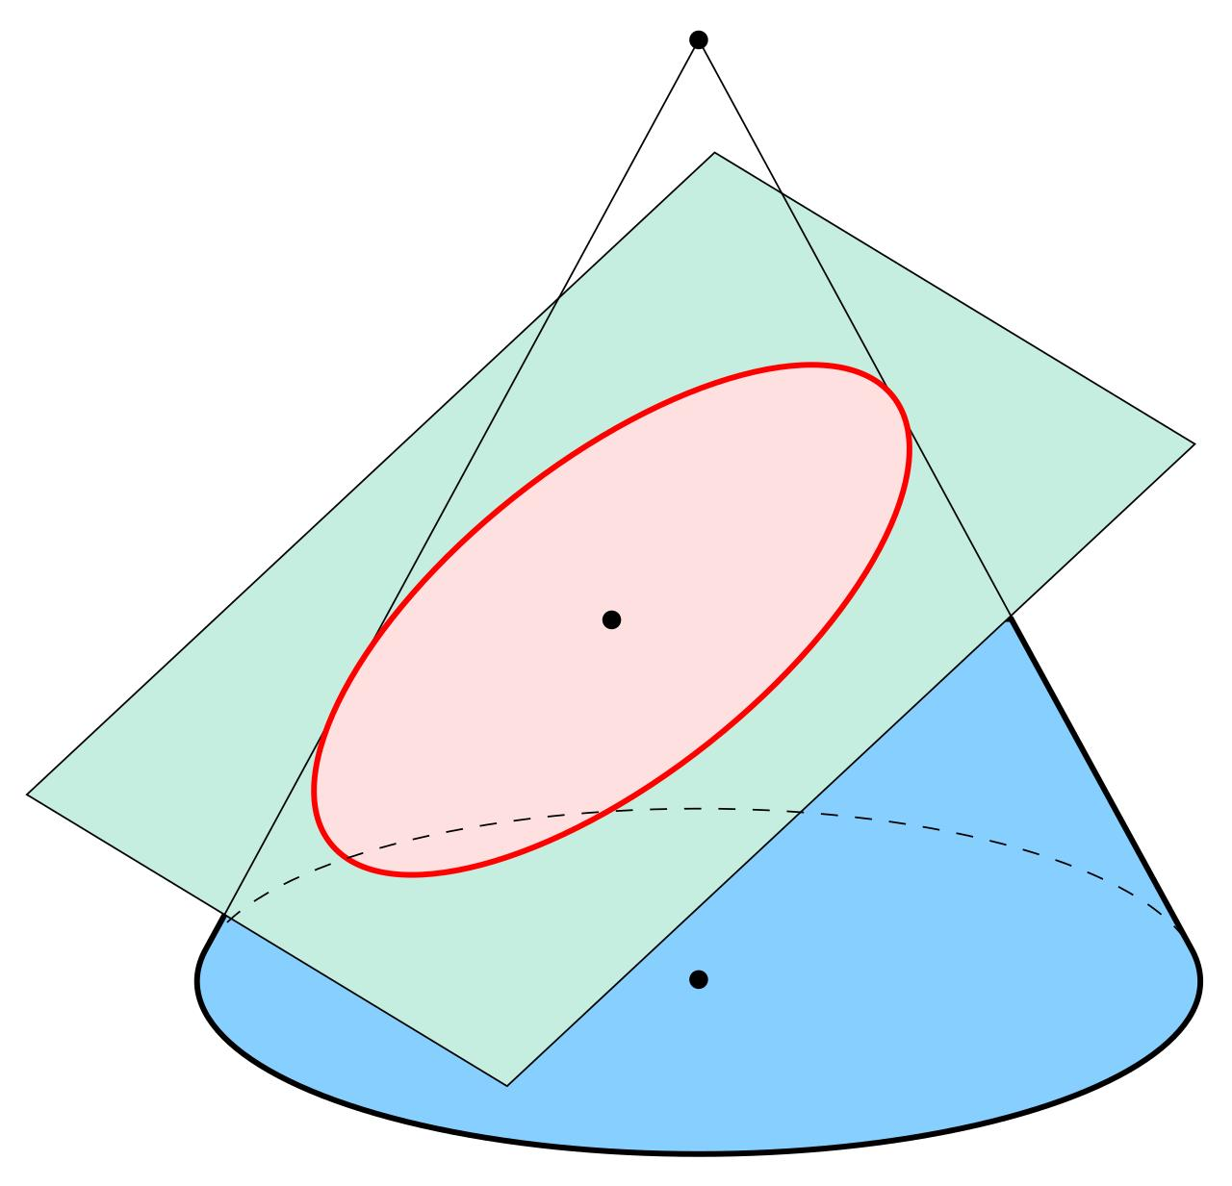
An elliptical cross section can be produced when a plane intersects one nappe of a double cone without being parallel to a generator.
- The cutting plane intersects the cone's lateral surface.
- The resulting boundary is an ellipse.
- A plane parallel to the base produces a circle, which is a special case of an ellipse.
- The section must be positioned appropriately; a finite cone's base can truncate the resulting region.

Ellipsoid
# Source: AI Source: Provided by: [Data Path: Persons Table -> ID Column: 1, Name_En Column: Motasem Essam] -> From: [ChatGPT] on [7/25/2026]
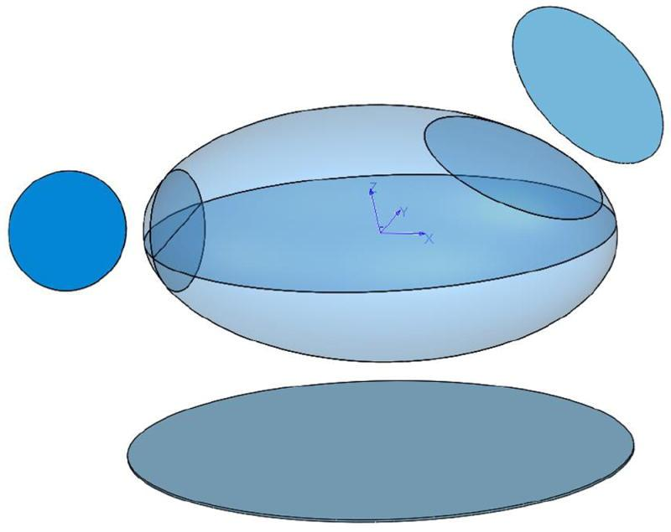
An ellipsoid produces an elliptical cross section when intersected by a plane through its interior.
- Its sections are generally ellipses.
- The section's dimensions depend on the plane's orientation and position.
- A section perpendicular to a symmetry axis of an ellipsoid of revolution is circular.
- A sphere produces circular sections for every plane that intersects its interior.

Elliptic Cylinder
# Source: AI Source: Provided by: [Data Path: Persons Table -> ID Column: 1, Name_En Column: Motasem Essam] -> From: [ChatGPT] on [7/25/2026]
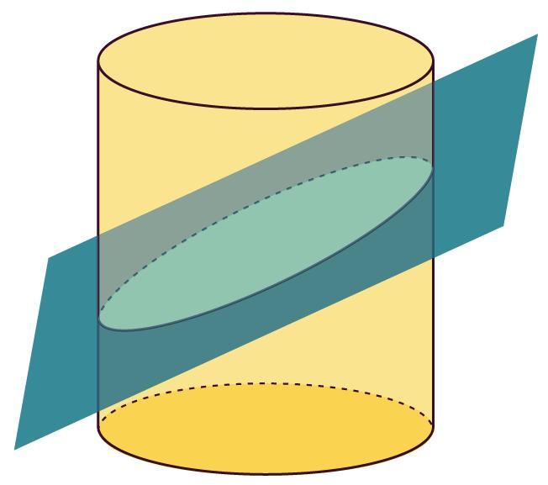
An elliptic cylinder can produce elliptical cross sections.
- A plane perpendicular to its axis produces an ellipse congruent to its base.
- An oblique plane that is not parallel to its axis produces an ellipse, provided the section is not clipped by the cylinder's ends.
- The dimensions of the ellipse depend on the base ellipse and the plane's inclination.

Hyperboloid of One Sheet
# Source: AI Source: Provided by: [Data Path: Persons Table -> ID Column: 1, Name_En Column: Motasem Essam] -> From: [ChatGPT] on [7/25/2026]
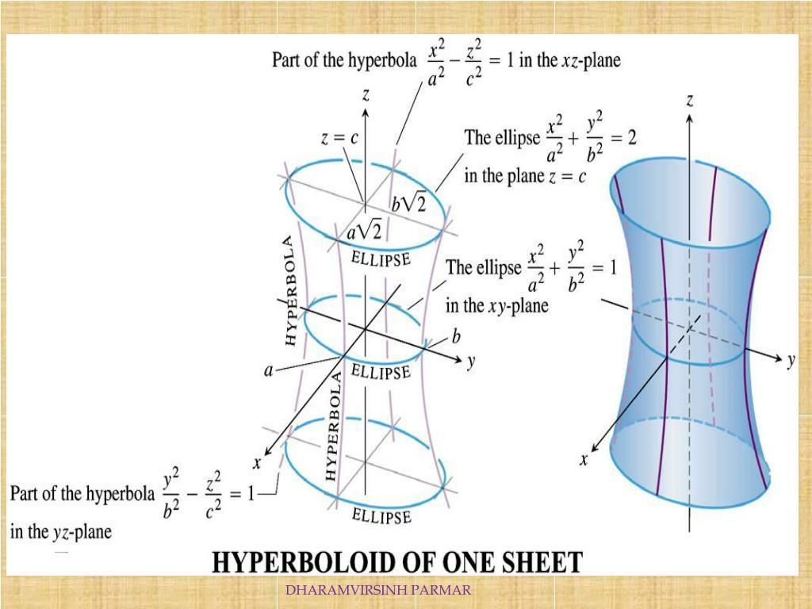
A horizontal plane perpendicular to the axis of a hyperboloid of one sheet produces an elliptical cross section.
- The section is generally an ellipse.
- Its size varies according to its position along the axis.
- A central horizontal section is the smallest elliptical section for the standard hyperboloid of one sheet.

Mathematical Representation

Standard Ellipse Equation
# Source: AI Source: Provided by: [Data Path: Persons Table -> ID Column: 1, Name_En Column: Motasem Essam] -> From: [ChatGPT] on [7/25/2026]
For an ellipse centered at the origin with a horizontal major axis:
$$\frac{x^{2}}{a^{2}}+\frac{y^{2}}{b^{2}}=1$$
Where:
- $a$ = semi-major axis.
- $b$ = semi-minor axis.
- $a≥b>0$.
For an ellipse with a vertical major axis, the denominators are exchanged:
$$\frac{x^{2}}{b^{2}}+\frac{y^{2}}{a^{2}}=1$$
For an ellipse centered at $(h,k)$:
$$\frac{(x-h)^{2}}{a^{2}}+\frac{(y-k)^{2}}{b^{2}}=1$$

Area
# Source: AI Source: Provided by: [Data Path: Persons Table -> ID Column: 1, Name_En Column: Motasem Essam] -> From: [ChatGPT] on [7/25/2026]
The area of an elliptical cross section is:
$$A=πab$$
Where $a$ and $b$ are the semi-major and semi-minor axes.

Eccentricity
# Source: AI Source: Provided by: [Data Path: Persons Table -> ID Column: 1, Name_En Column: Motasem Essam] -> From: [ChatGPT] on [7/25/2026]
The eccentricity measures how much the ellipse differs from a circle.
$$e=\sqrt{1-\frac{b^{2}}{a^{2}}}$$
Where:
$$0≤e<1$$
- $e=0$: Circle.
- $0<e<1$: Non-circular ellipse.
- As $e$ approaches 1, the ellipse becomes increasingly elongated.

Focal Distance
# Source: AI Source: Provided by: [Data Path: Persons Table -> ID Column: 1, Name_En Column: Motasem Essam] -> From: [ChatGPT] on [7/25/2026]
The distance from the center to either focus is:
$$c=\sqrt{a^{2}-b^{2}}$$
The distance between the two foci is:
$$F=2c$$

Elliptical Perimeter
# Source: AI Source: Provided by: [Data Path: Persons Table -> ID Column: 1, Name_En Column: Motasem Essam] -> From: [ChatGPT] on [7/25/2026]
Unlike a circle, an ellipse does not have a simple exact perimeter formula using elementary functions.
A useful approximation is Ramanujan's formula:
$$P≈π\left[3(a+b)-\sqrt{(3a+b)(a+3b)}\right]$$

Ellipsoid Cross-Section Equation
# Source: AI Source: Provided by: [Data Path: Persons Table -> ID Column: 1, Name_En Column: Motasem Essam] -> From: [ChatGPT] on [7/25/2026]
For an ellipsoid centered at the origin:
$$\frac{x^{2}}{a^{2}}+\frac{y^{2}}{b^{2}}+\frac{z^{2}}{c^{2}}=1$$
A horizontal plane at $z=z_{0}$ produces:
$$\frac{x^{2}}{a^{2}(1-z_{0}^{2}/c^{2})}+\frac{y^{2}}{b^{2}(1-z_{0}^{2}/c^{2})}=1$$
For:
$$|z_{0}|<c$$
The semi-axes of the resulting ellipse are:
$$a_{s}=a\sqrt{1-\frac{z_{0}^{2}}{c^{2}}}$$
$$b_{s}=b\sqrt{1-\frac{z_{0}^{2}}{c^{2}}}$$
This demonstrates how the elliptical section changes size as the cutting plane moves along the ellipsoid's vertical axis.

Mathematical Properties
# Source: AI Source: Provided by: [Data Path: Persons Table -> ID Column: 1, Name_En Column: Motasem Essam] -> From: [ChatGPT] on [7/25/2026]
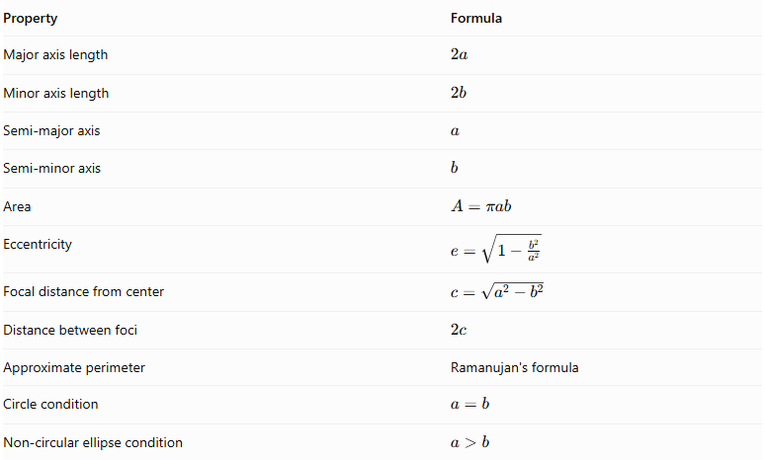
Property | Formula
Major axis length | $$2a$$
Minor axis length | $$2b$$
Semi-major axis | $$a$$
Semi-minor axis | $$b$$
Area | $$A=πab$$
Eccentricity | $$e=\sqrt{1-\frac{b^{2}}{a^{2}}}$$
Focal distance from center | $$c=\sqrt{a^{2}-b^{2}}$$
Distance between foci | $$2c$$
Approximate perimeter | Ramanujan's formula
Circle condition | $$a=b$$
Non-circular ellipse condition | $$a>b$$

Elliptical Cross Section vs. Other Cross-Section Shapes
# Source: AI Source: Provided by: [Data Path: Persons Table -> ID Column: 1, Name_En Column: Motasem Essam] -> From: [ChatGPT] on [7/25/2026]
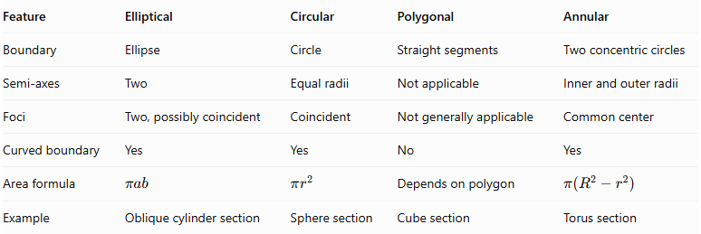
Feature | Elliptical | Circular | Polygonal | Annular
Boundary | Ellipse | Circle | Straight segments | Two concentric circles
Semi-axes | Two | Equal radii | Not applicable | Inner and outer radii
Foci | Two, possibly coincident | Coincident | Not generally applicable | Common center
Curved boundary | Yes | Yes | No | Yes
Area formula | $$πab$$ | $$πr^{2}$$ | Depends on polygon | $$π(R^{2}-r^{2})$$
Example | Oblique cylinder section | Sphere section | Cube section | Torus section

Applications
# Source: AI Source: Provided by: [Data Path: Persons Table -> ID Column: 1, Name_En Column: Motasem Essam] -> From: [ChatGPT] on [7/25/2026]
- Engineering: Analyzing inclined cuts through cylindrical and elliptical components.
- Architecture: Designing elliptical arches, curved structures, and structural profiles.
- Mechanical Engineering: Studying pipes, shafts, and components with elliptical sections.
- Manufacturing: Determining the geometry of angled cuts through cylindrical materials.
- Mathematics: Studying conic sections, ellipses, and plane intersections.
- Computer Graphics: Modeling and rendering elliptical surfaces and cross-sectional profiles.
- Physics: Analyzing elliptical trajectories and geometric sections of three-dimensional objects.

Main Classification
# Source: AI Source: Provided by: [Data Path: Persons Table -> ID Column: 1, Name_En Column: Motasem Essam] -> From: [ChatGPT] on [7/25/2026]
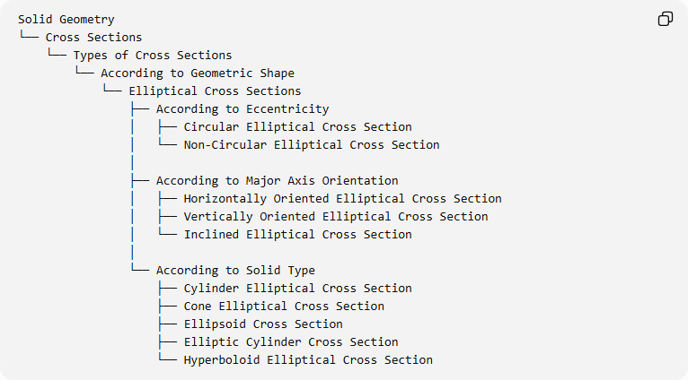
Solid Geometry
└── Cross Sections
└── Types of Cross Sections
└── According to Geometric Shape
└── Elliptical Cross Sections
├── According to Eccentricity
│ ├── Circular Elliptical Cross Section
│ └── Non-Circular Elliptical Cross Section
│
├── According to Major Axis Orientation
│ ├── Horizontally Oriented Elliptical Cross Section
│ ├── Vertically Oriented Elliptical Cross Section
│ └── Inclined Elliptical Cross Section
│
└── According to Solid Type
├── Cylinder Elliptical Cross Section
├── Cone Elliptical Cross Section
├── Ellipsoid Cross Section
├── Elliptic Cylinder Cross Section
└── Hyperboloid Elliptical Cross Section

Key Points
# Source: AI Source: Provided by: [Data Path: Persons Table -> ID Column: 1, Name_En Column: Motasem Essam] -> From: [ChatGPT] on [7/25/2026]
- An elliptical cross section is a two-dimensional region bounded by an ellipse.
- It has a major axis, minor axis, center, and two foci.
- Its area is calculated using $A=πab$.
- A circle is a special case of an ellipse where $a=b$.
- Oblique sections of suitable right circular cylinders can produce ellipses.
- Suitable plane sections of cones produce ellipses.
- Every non-tangent plane section through the interior of an ellipsoid produces an elliptical region.
- The orientation and position of the cutting plane determine the dimensions and orientation of the resulting ellipse.

Conclusion
# Source: AI Source: Provided by: [Data Path: Persons Table -> ID Column: 1, Name_En Column: Motasem Essam] -> From: [ChatGPT] on [7/25/2026]
Elliptical Cross Sections are two-dimensional regions formed when suitable planes intersect three-dimensional solids. They are characterized by their major and minor axes, eccentricity, and focal properties. They commonly occur in cylinders, cones, ellipsoids, and hyperboloids, making them important in conic geometry, engineering, architecture, and three-dimensional modeling.

